Docker Compose

Trying With Docker File to deploy war to tomcat

root@ip-172-31-18-205:~/Bootcamp/dockercompose/war-test# docker image build -t sowmya2306tcs/tomcatwar:1.0 .

Sending build context to Docker daemon 131.6kB

Step 1/3 : FROM tomcat:8.0.20-jre8

8.0.20-jre8: Pulling from library/tomcat

a3ed95caeb02: Pull complete

c06482b548c8: Pull complete

954f07d4dc14: Pull complete

0bd71cf3b59f: Pull complete

12d3f8630eca: Pull complete

d6e16c3ae29a: Pull complete

ea9df2460d2a: Pull complete

66a4ea6d102d: Pull complete

2b6aeca0d35e: Pull complete

Digest: sha256:579e042fb31e6975062276489cbdb3d9c942661a1d489f122d29ce2249e2ed34

Status: Downloaded newer image for tomcat:8.0.20-jre8

---> e88a065848be

Step 2/3 : COPY /target/war-test.war /usr/local/tomcat/webapps/myapp.war

---> 0648056aed9d

Step 3/3 : MAINTAINER "sowmya2306@gmail.com"

---> Running in 3e1faab700c7

Removing intermediate container 3e1faab700c7

---> 431ef4552199

Successfully built 431ef4552199

Successfully tagged sowmya2306tcs/tomcatwar:1.0

root@ip-172-31-18-205:~/Bootcamp/dockercompose/war-test# docker image ls

REPOSITORY TAG IMAGE ID CREATED SIZE

sowmya2306tcs/tomcatwar 1.0 431ef4552199 24 seconds ago 493MB

root@ip-172-31-18-205:~/Bootcamp/dockercompose/war-test# docker run -p 9091:9091 -d sowmyatcs2306/tomcatwar:1.0

f75da86eeda3a073af7be11ced8d9734150755c8a4f7f54d1b07bf0b6fdc82c6

root@ip-172-31-18-205:~/Bootcamp/dockercompose/war-test# docker ps

CONTAINER ID IMAGE COMMAND CREATED STATUS PORTS NAMES

f75da86eeda3 sowmyatcs2306/tomcatwar:1.0 "catalina.sh run" 5 seconds ago Up 3 seconds 8080/tcp, 0.0.0.0:9091->9091/tcp recursing_swartz

e5f7a3acb57c sowmyatcs2306/springboot:1.0 "java -jar app.jar" 38 minutes ago Up 38 minutes 8080/tcp, 0.0.0.0:9090->9090/tcp eloquent_nobel

Docker Command to login to container and check the deployed war in tomcat

root@ip-172-31-18-205:~/Bootcamp/dockercompose/war-test# docker container exec -it recursing_swartz bash

root@f75da86eeda3:/usr/local/tomcat# ls

LICENSE NOTICE RELEASE-NOTES RUNNING.txt bin conf lib logs temp webapps work

root@f75da86eeda3:/usr/local/tomcat# cd webapps/

root@f75da86eeda3:/usr/local/tomcat/webapps# ls

ROOT docs examples host-manager manager myapp myapp.war

Docker File

FROM tomcat:8.0.20-jre8

COPY /target/war-test.war /usr/local/tomcat/webapps/myapp.war

MAINTAINER [sowmya2306@gmail.com](mailto:sowmya2306@gmail.com)

CMD ["catalina.sh", "run"]

Output :

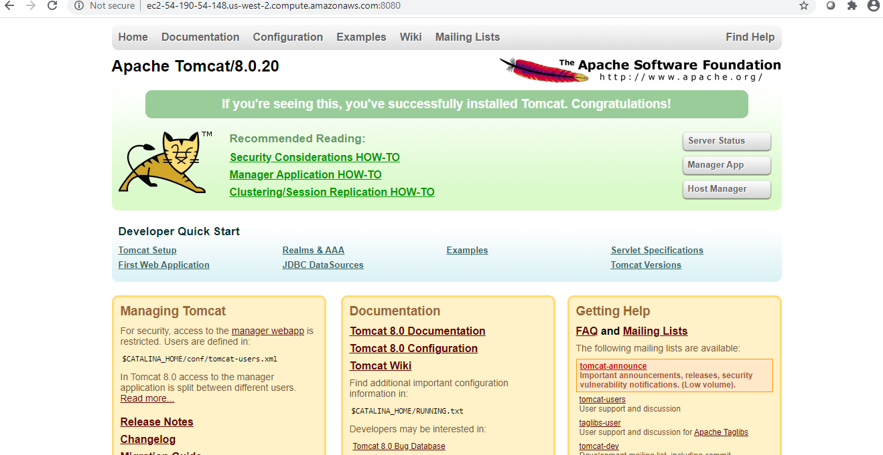

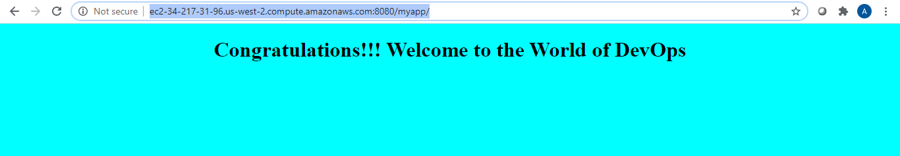

Docker Compose

db:

image: mysql:latest

environment:

MYSQL_ROOT_PASSWORD: 123

#MYSQL_DATABASE: sample

#MYSQL_USER: test_user

#MYSQL_PASSWORD: test

web:

image: sowmyatcs2306/tomcatwar:1.0

ports:

- "9092:9092"

ubuntu@ip-172-31-18-205:~$ docker ps

CONTAINER ID IMAGE COMMAND CREATED STATUS PORTS NAMES

3aee035bdaf8 mysql:latest "docker-entrypoint.s…" 27 seconds ago Up 25 seconds 3306/tcp, 33060/tcp dockercompose_db_1

cd7fc7e0bcce sowmyatcs2306/tomcatwar:1.0 "catalina.sh run" 31 minutes ago Up 25 seconds 8080/tcp, 0.0.0.0:9092->9092/tcp dockercompose_web_1

Curl to war

ubuntu@ip-172-31-18-205:~/Bootcamp/dockercompose$ curl <http://localhost:8080/>





MySQL Installation

**ubuntu@ip-172-31-18-205:~/Bootcamp/dockercompose$ docker exec -it 3aee035bdaf8 /bin/bash**

**root@3aee035bdaf8:/# mysql --version**

**mysql Ver 8.0.21 for Linux on x86_64 (MySQL Community Server - GPL)**

**root@3aee035bdaf8:/#**